**Functionality:**

**There is Home page- where you choose to search or update question.**



**On Search page – Give a question and on click of search it returns the answers stored in the DB**



**MySQL Database:**

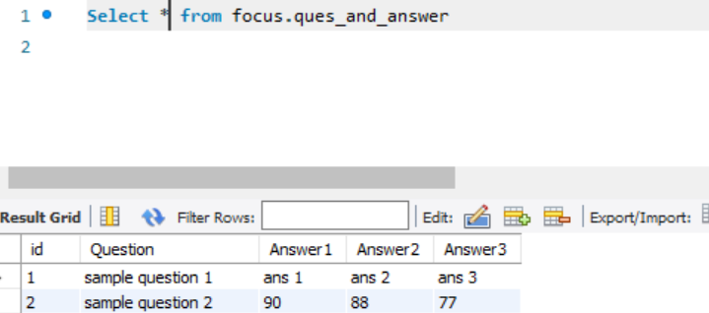

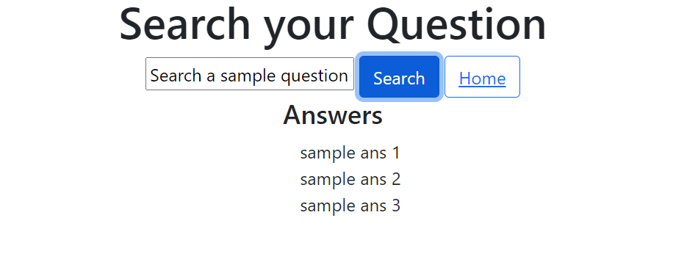

**On Update page – give a question & respective answers. Respective questions will be updated in the DB.**

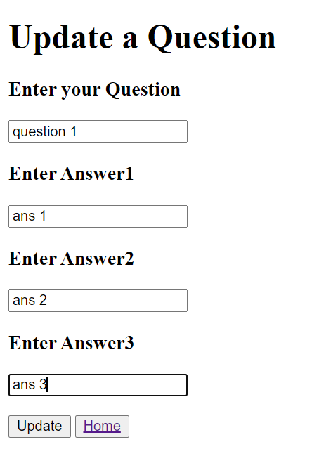

**On update Pop up is displayed**

